**Task 3**

Get me the IP address of a particular domain (guvi.in) 2. How do I find the CPU/memory usage of my server? 3. Test the connectivity between 2 nodes.

IP address for guvi.in

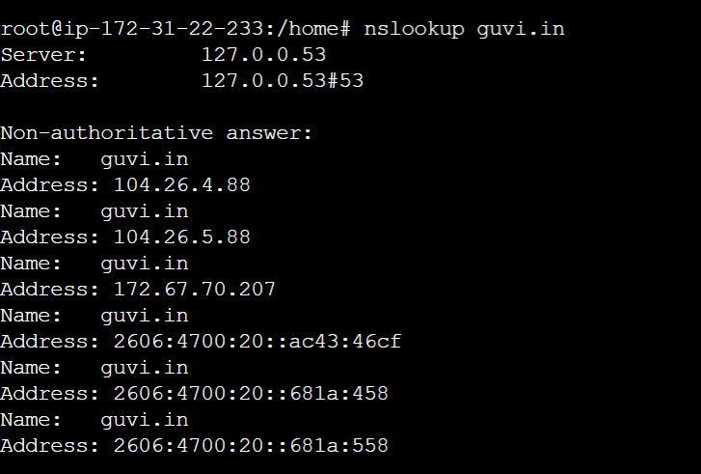

CPU Usage and memory usage

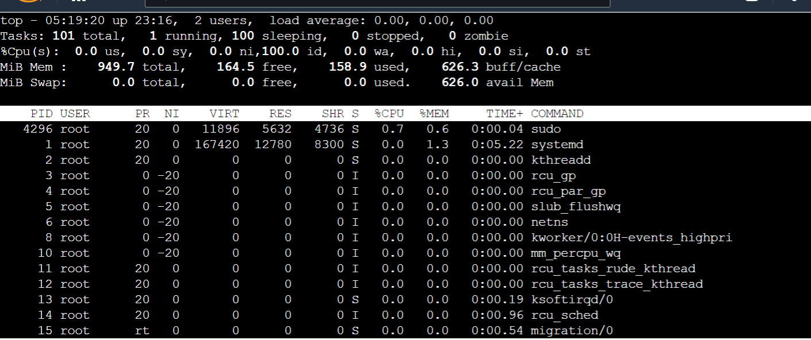

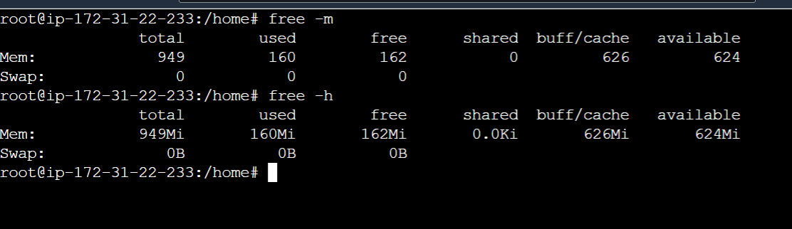

Testing 2 node connectivity

